Download the “RDS Unite” App
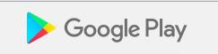
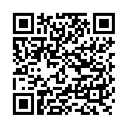 | 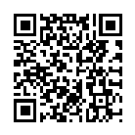
Enter your church code:
<Church Code>
For More information: YouTube “Introducing RDS Unite”
